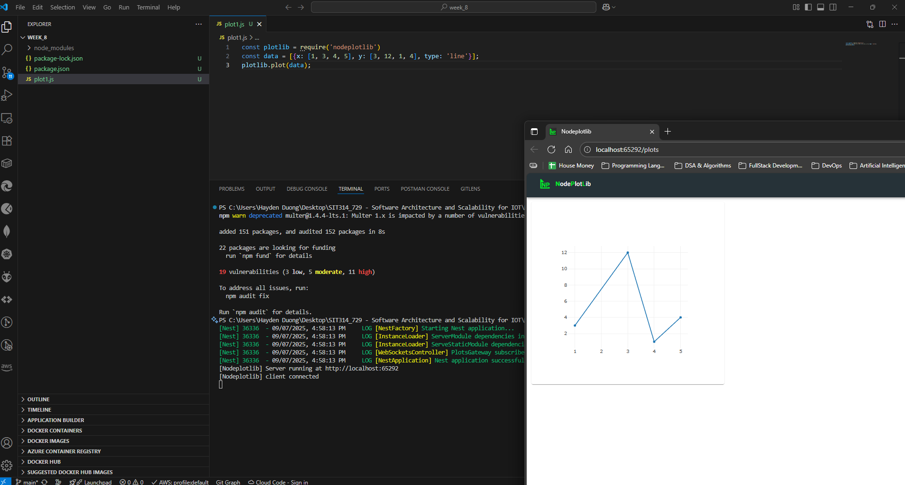
Picture 1 – Graph generated from “plot1.js”
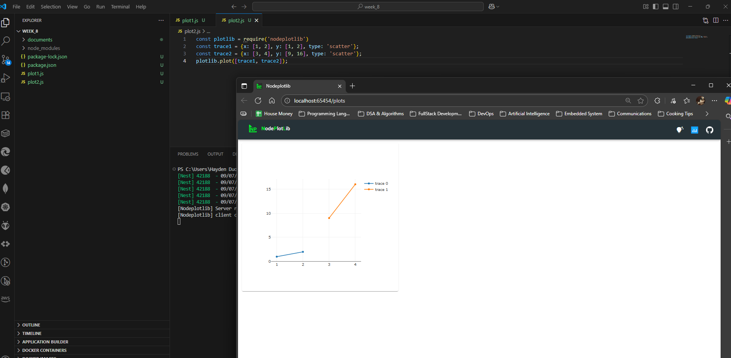
Picture 2 – Graph generated from “plot2.js”
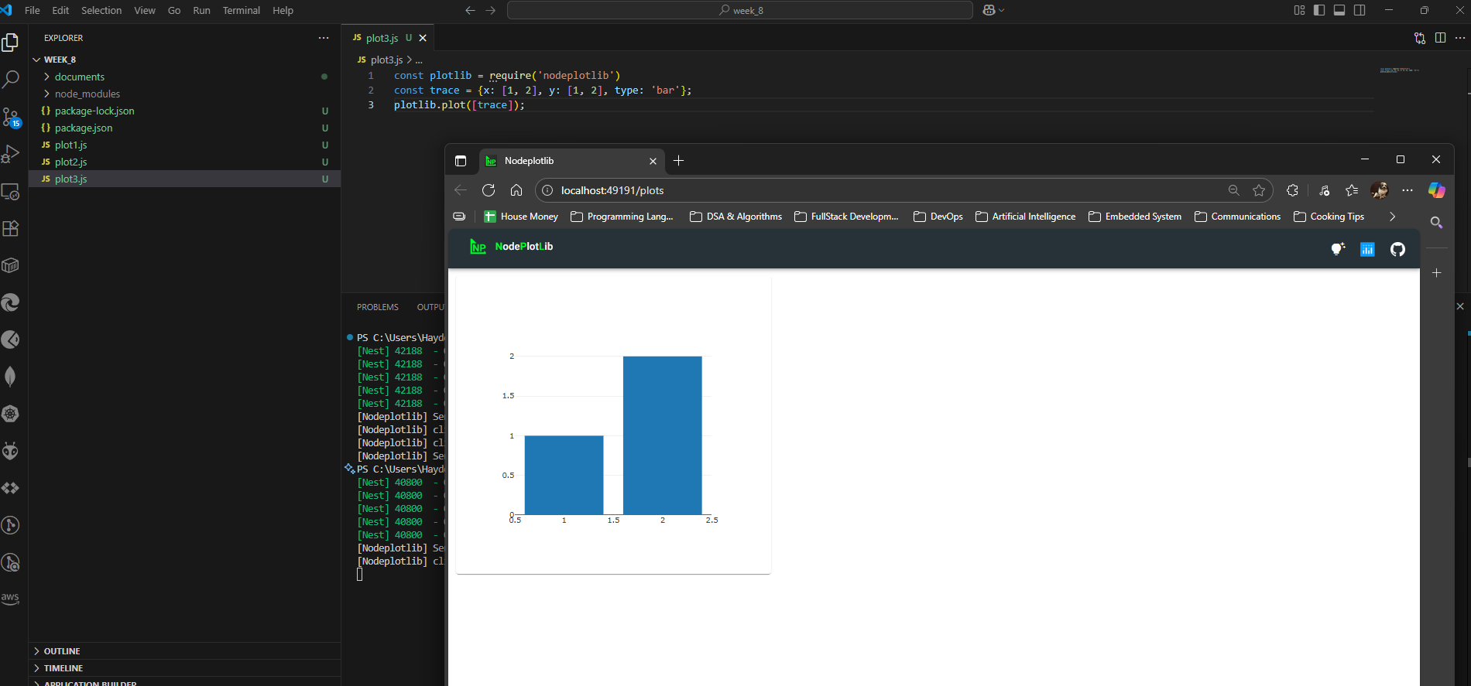
Picture 3 - Graph generated from “plot3.js”
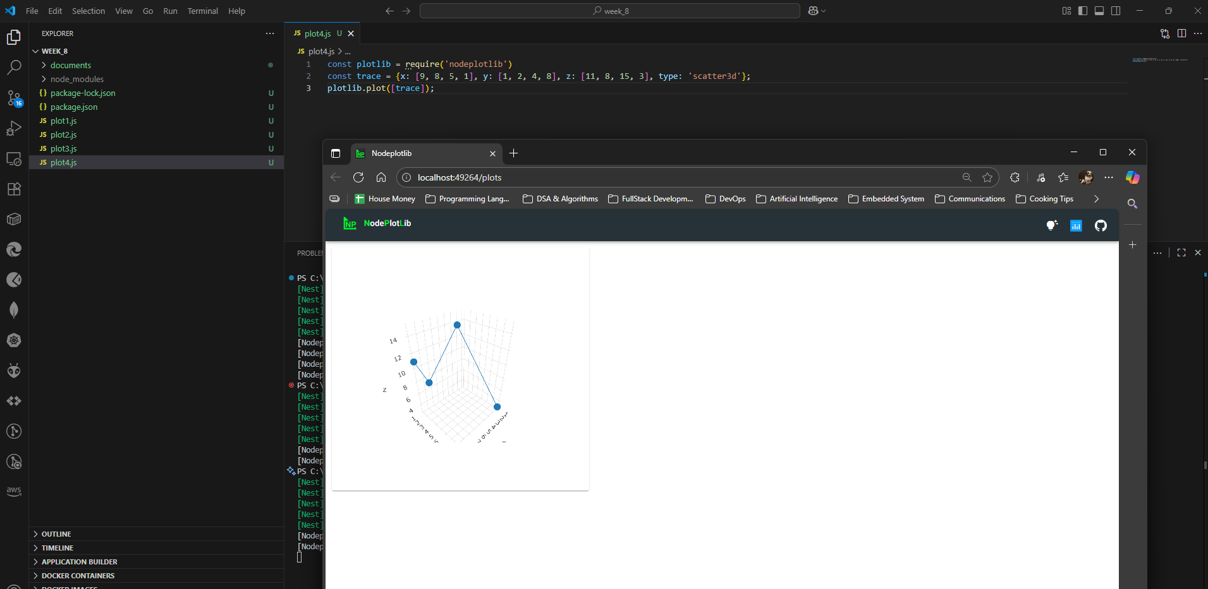
Picture 4 – Graph generated from “plot4.js”
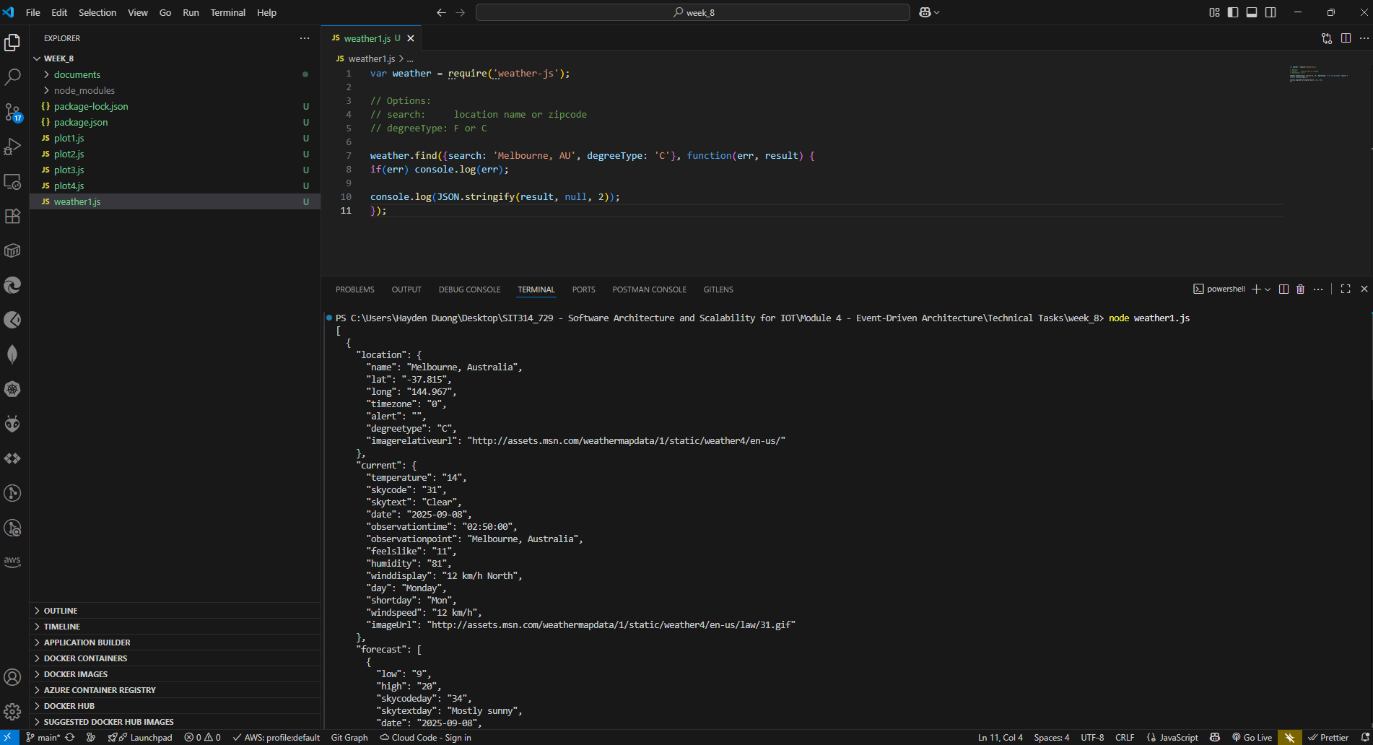
Picture 5 – Result gained from running “weather1.js”
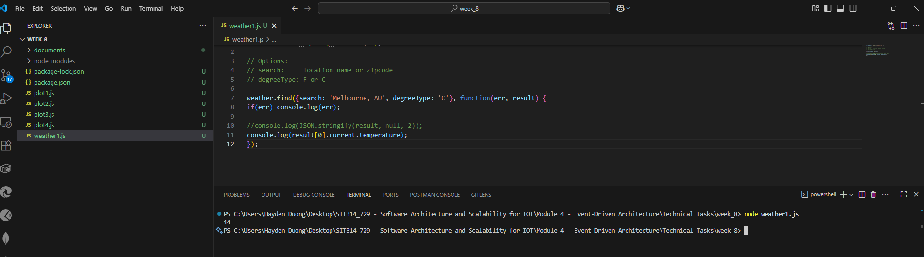
Picture 6 – Result gained from step 4 of “Accessing a data API using a module”
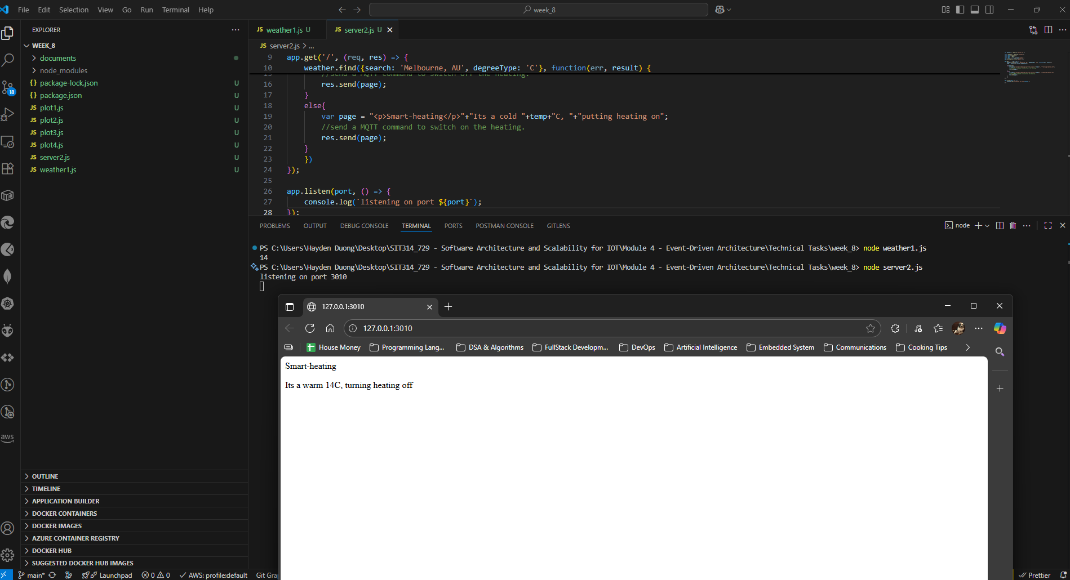
Picture 7 – Result gained from running “server2.js”

